INTERNAL MOCK EXAMINATIONS – 2018
Uganda Advanced Certificate of Education
BIOLOGY P530/1
MARKING GUIDE

SECTION A
1. B 11. B 21. B 31. A
2. D 12. B 22. C 32. C
3. C 13. C 23. D 33. D
4. C 14. C 24. D 34. C
5. B 15. D 25. B 35. A
6. B 16. B 26. A 36. C
7. B 17. D 27. B 37. A
8. A 18. B 28. A 38. B
9. D 19. C 29. A 39. B
10. B 20. C 30. B 40. B
41. (a) Altruistic behaviours are activities carried out by one organism so as to
promote the survival of an other organization of the same species; some times at the expense of its own life; e.g. parental care; while rhythinical behaviour is where an organisms carries out activities at regular intervals irrespective of the season or day length; e.g. breeding seasons; biannual migrations, annual hibernation, daily rhythms. (04 marks)

(b) (i) In both organisms, the more trials the fewer the errors/ the more the,
Learning;
  - Rat commits less errors and masters the maze faster than the ant;
  - Learning in the rat is less erratic/ rat remembers previously learned information more than the ant;
Accept, - Rat completely stops to error where as the ant continues to error.

(ii) The type of motivation/ reward/ organisms state of readiness to learn;
- Complexity of the maze / situation;
- Level of development of nervous systems;

Accept, - Intelligent quotient of the organism.
- Age of an organism.
- Peer influence.

42. (a) Saitier sweat
  - Abnormally thick mucus;
  - Diabetes;
  - Digestive problems;
Accept, - Deformed limbs;
(b) Le C represents the gene for normal
  - Let C represents the gene for cystic fibrosis

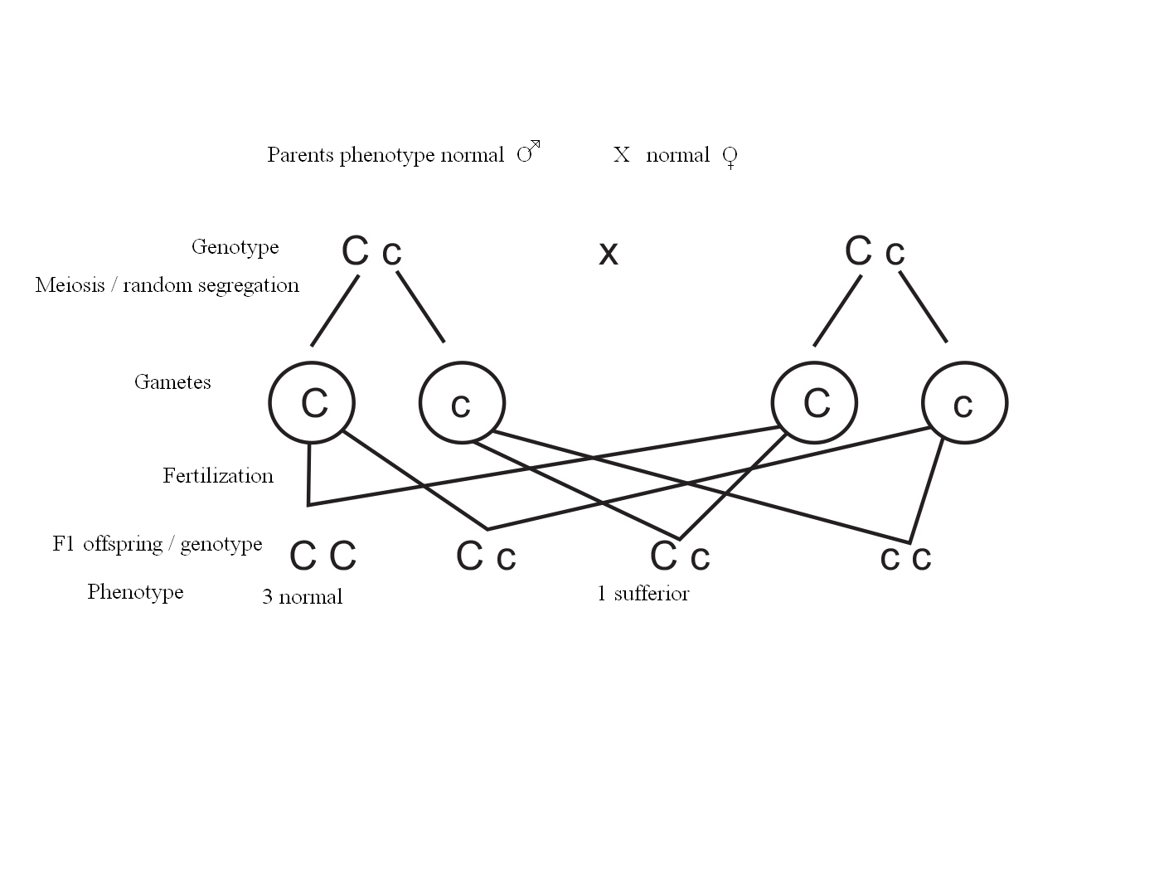
The probability is = ¼
Or ¼ x 100
= 25%

Phenotype 3 normal 1 sufferer
F1 offspring /genotype
Fertilization
Genotype
Meiosis / random
segregation
Parents phenotype normal O X normal O;

(ii) Allopolyploid is where the whole sets of chromosomes added in the
cell; arise from sets of chromosomes from more than one different
species of organisms; (02 marks)

43. (a) Use of a counter current exchanger/ system; heat from the warm blood; in
the arteries; flows/ transferred to the cold blood in the veins; returning
blood to the body lowering the limb temperature compared to the core
temperature; (05 marks)

(b) (i) Efficient : Graph A;
Inefficient: Graph B; (½ mark)

(ii) Graph A shows a very efficient homeostatic system because there are
very slight/ little fluctuations; from the set point / normal; hence the
corrective response to the deviation is immediately triggered/ effected;
to restore the horm; (03 marks)
The inefficiency showed by graph B is seen by very large deviations
from the norm/ set point; hence the corrective mechanism takes longer
time to restore the norm;

(c) - Regulation of glucose
  - Regulation of lipids
  - Regulation of amino acids
  - Detoxification
  - Production of bile
  - Formation of cholesterol
  - Elimination of sex hormones
  - Formation of RBCs
  - Elimination of hemoglobin
  - Production of bile
  - Synthesis of plasma protein
  - Storage of blood
  - Storage of vitamins
(Accept any 2 points)

44. (a) Photoperiodism is the response of organisms to changing lengths of the day
and night periods (light periods); while varnalization is the exposure of a
plant to very low temperature requirements to induce flowering; (02 marks)

(b) (i) D. Short day plant; requires shorter days than critical lengths to flower;
E. Day neutral; not affected by day length in order to flower;
F. Long day plant; requires more dark period than critical length to
flower;

(ii) (D) Long dark periods favour the conversion of PFR topr; which
stimulates flowering; F Long exposure to light; favours accumulation
of PFR which stimulates flowering; (04 marks)

45. (a) (i) Is the development an embryo from unfertilized haploid eggs; that are
formed by meiosis; and may develop directly into haploid off spring;
(03 marks)
(ii) Is the development of embryo from unfertilized diploid eggs; formed
from mitosis instead of meiosis; resulting into diploid offspring which are
clones of the parent; (03 marks)

(b) Pollen tube nucleus controls the growth of pollen tube down the style to the
embryo sac; The generative nucleus divides mitotic; to form two male
nuclear to ensure double fertilization to form a zygote and endosperm;

(c) Lack vascular bundles for water transport;
Lack cuticle which could minimize water loss in dry areas;
Require water for movement of gametes;
Lack true roots for water absorption;
(Any 3 points)
46. (a) Pancreozymin.
(i) Stimulates the pancreas to secrete digestive enzymes;
Stimulates the gall bladder to release bile
  - Gastrin hormone: stimulates gastric glands to secrete gastric juice;
  - Secretin- stimulates the liver to secrete bile;
  - Stimulates the pancreas to secrete the non- enzymatic components of pancreatic juice;
(b) Carbondioxide reacts with water in presence of enzyme carbonic anhydrase;
to form a weak acid, carbonic acid which readily dissociates to form H+ and
HCO₃ -; carbonic anhydrase catalyses this reaction where, H+ combine with
Cl to form HCI; (03 marks)

- (i) A, CO₂
B, Malic acid accept mallate.
C, Carbohydrate glucose/ hexose sugar
D, Pyruvic acid accept pyruvate.
(ii) Palisade cell
Bundle sheath cell
(iii) Maize, sugar cane, grasses, some amaranthus SPP, sorghum, any 2

END

